ADIL MUHAMMAD

BSc (Hons) Computer science

Module 5: Front end

Module Co-ordinator: Ahmad Alam​

Content table:

|  |  |
| --- | --- |
| *Topic* | *Page* |
| Requirements Gathering methods | 3 |
| Key Requirements | 4 |
| User Guide | 5 |
| Accessibility | 8 |
| References | 10 |
|  |
|  |

Requirement Gathering Methods

Requirements are one of the most vital pieces to ensuring the success of a system or project.one reason why requirements are really important is because Poor requirements can have a significant impact on the end results of the website therefore making sure we get them right we will use various requirement’s methods.

Group Interviews: A group interview is when an employee or team of employees interviews multiple candidates at the same time this will be useful as this website will have a lot of stakeholders which therefore means that using one to one interview can be expensive and time consuming. one advantages for using group interviews is that More thoughts and discussion can be generated, as someone in the group may state or suggest an idea that may have been overlooked by others which may lead to better website being built.

Questionnaires/Surveys: Questionnaires, or surveys, allow an analyst to collect information from many people in relatively short amount of time this is really useful for this website as company may ask customer to fill in these Questionnaires/Surveys as they will be the primary user of the website and there input would be essential however as this will be international travel agency therefore it may mean that customers will be spread out geographically and therefore doing interviews especially during pandemic(covid 19) can be expensive and costly and using Questionnaires/Surveys would be better option.

Identify Key Stakeholders:

there are various ways of collecting data one way data collection can be done is by identifying the key stakeholders this will involve anyone effected by the website this will include sponsors of the website etc then it can be done by identifying the people who will use this website which may include customers. the whole website is intended for customer therefore it will be very important to get their input in this this will also include customers who are visually impaired as they may have other requirements.

Capturing requirement’s:

Second stage will include interviewing these people by using various methods such as questioners and group interviews. Group interviews are particularly useful as This will help us understand how information flows between different divisions or departments and ensure that handovers will be managed smoothly Furth more to decide on what programming language to use, management can have a look at most popular programming languages and decide which one would be suitable and cost effective for the website.

##### Building prototypes:

Third stage may include prototype of website to give users an idea of what the final product will look like. Using this, users can address feasibility issues, and they can help identify any inconsistencies and problems. this stage will also include different requirements such as functional and non-functional.

##### Sign Off:

Last stage will include getting signed agreement of key stakeholders, or representatives of key stakeholder groups, saying that the requirements as presented precisely reflect their needs and from there work will be carried out.

System Requirements to use Your Trip website

Supported Browsers

This website optimized for the following internet browsers:

Internet Explorer: IE 9, IE 10, IE11

Firefox: 26, 28, 29

Google Chrome: 33, 34, 35

Safari 7.x

Any android above 4.0 or iOS 12

Supported Screen resolution

Following screen resolutions are supported by this website.

1920x1080

1366x768

1024x768

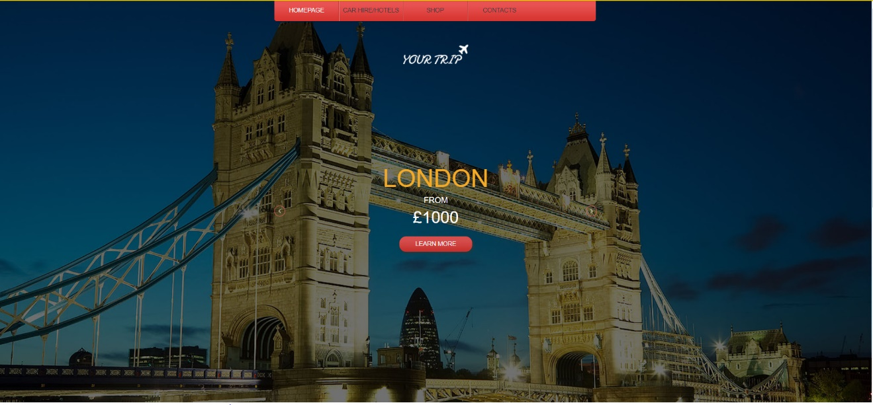User Guide

This website allows customers to request and book trips online and to make modifications and fulfilment of existing bookings. The link file:///C:/Users/adil/Desktop/website/main/index.html guides you to the main homepage of this website. On the top of webpage there are different buttons that let u navigate through different pages such as shop page or contact us page. By clicking on learn more page it will take you to the shop page for you to make any purchases.

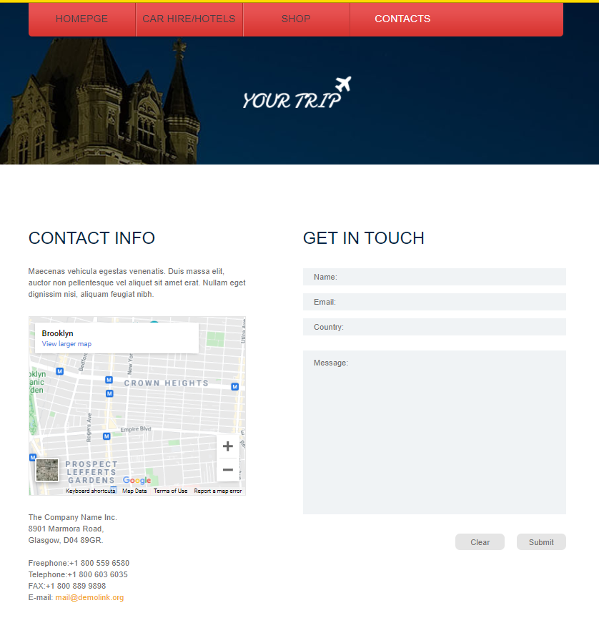

The following screen provides the travel agency user with contacting the agency regarding any information they require Furth more this also provides them with a place where they can find all your contact details easily and a map if they are planning to visit the agency or inquire about the issue, they are having.

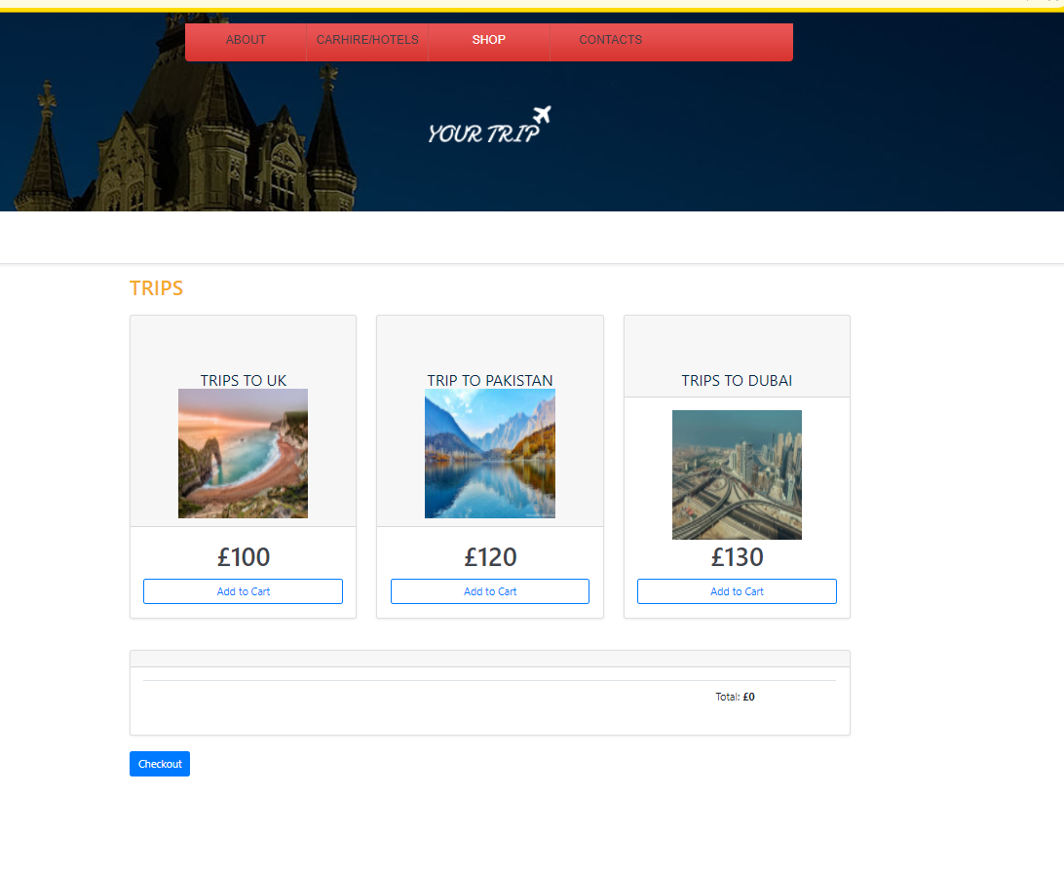

The following screen provides the travel agency user to be able to add different trips to the cart .by clicking on add to cart button it will allow the user to add the item in the cart. It also allows user to add the quantity of the trips or remove the trips if it required as shown in the picture below. This also allows user to move around pages freely and still keep the items they have added in the basket.

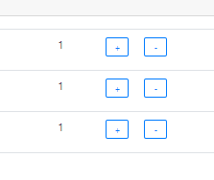

There is a checkout buttons that allows user to check out safely and shows a messages Furth more there is an empty cart buttons which allows the user on the site to delete everything in their cart making it easier for user to easier to use this site. This can be seen in the pictures below.

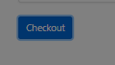

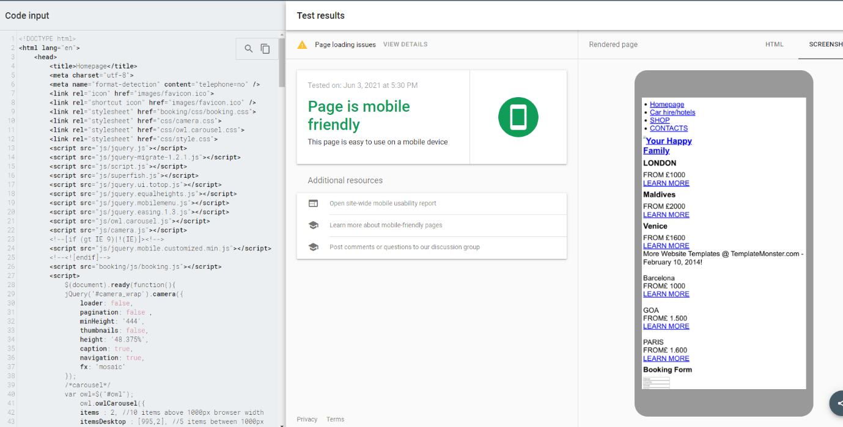Another feature of this website is that it has integrated bootstrap which therefore mean that it is mobile friendly, and this was checked by Mobile friendly test this is a really important feature as Mobile accounts for approximately half of web traffic worldwide. In the first quarter of 2021, mobile devices (excluding tablets) generated 54.8 percent of global website traffic.

Web accessibility

Web accessibility means that websites, tools, and technologies are designed and developed so that people with disabilities can use them. At least 1 in 5 people in the UK have a long-term illness, impairment or disability therefore including these people is really important for this travel agency website.one way I have implemented accessibility check in my website is by using e “alt” text for non-decorative images therefore meaning that it gives these users alternative means to convey the information therefore keeping them engaged and included in the website .this can be seen the in the picture below



Originally I was planning to have dark colours such as green and red however to meet the WCAG accessibility guidelines You can’t use certain shades of red or green without triggering issues for people with red-green colour blindness I have decided to go for simple and light colours such as white and black to make sure it is easily readable with visual issues Furth more to comply with accessibility guidelines I have changed the text size to 11 as the minimum size should be 9

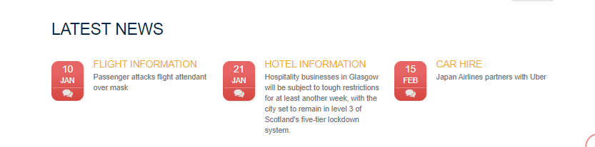

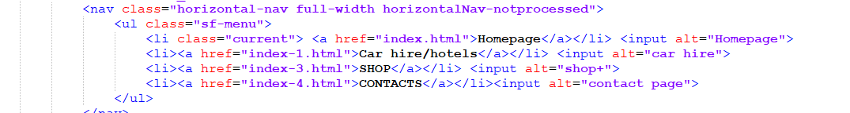One other way to help people with visual issue is by adding Including descriptive link names which was done through out this website to make sure it is accessible by everyone using it this was done on navigation buttons as they are red and may trigger people red-green colour blindness.

## One other way I made this website more accessible is by not adding key information such as latest flight news in .CSS this is due to the reason that screen readers do not read any CSS and therefore meaning that it will be easier for user to obtain any information as I have used html for key information.

## 

Some users may not be able to use a mouse or trackpad, accessing content only through the use of a keyboard these type of user rely on use of TAB button this would include Providing keyboard shortcuts wherever possible Avoiding using elements that only activate on mouse hover and that was something I wanted to add to my website however this was not possible due to not having enough time and resources to do however this will be something I will include in website if I were to make it again.one other thing that could be improved is using right tools such as accessibility checker to make sure it is accessible however I have used tools such as colour contrast checkers and browser extensions like the Axe tool to make sure it meets criteria set by w3c accessibility guideline

Reference list

Themezy. 2021. *Travel Agency Free Responsive Website Template*. [online] Available at: <https://www.themezy.com/free-website-templates/138-travel-agency-free-responsive-website-template> [Accessed 2 June 2021].

Code pen. 2021. *Add to cart*. [online] Available at: <https://codepen.io/PurpleTigress/pen/eXPxxq> [Accessed 2 June 2021].

Umsl.edu. 2021. *Requirement Gathering Methods*. [online] Available at: <https://www.umsl.edu/~sauterv/analysis/F2015/Requirement%20Gathering%20Methods.html.htm> [Accessed 2 June 2021].

Mindtools.com. 2021. *Business Requirements Analysis: Clearly Agreeing What You're Going to Deliver*. [online] Available at: <https://www.mindtools.com/pages/article/newPPM_77.htm> [Accessed 2 June 2021].

(WAI), W., 2021. *Colors with Good Contrast*. [online] Web Accessibility Initiative (WAI). Available at: <https://www.w3.org/WAI/perspective-videos/contrast/> [Accessed 4 June 2021].

(WAI), W., 2021. *Colors with Good Contrast*. [online] Web Accessibility Initiative (WAI). Available at: <https://www.w3.org/WAI/perspective-videos/contrast/> [Accessed 4 June 2021].

(WAI), W., 2021. *Colors with Good Contrast*. [online] Web Accessibility Initiative (WAI). Available at: <https://www.w3.org/WAI/perspective-videos/contrast/> [Accessed 4 June 2021].